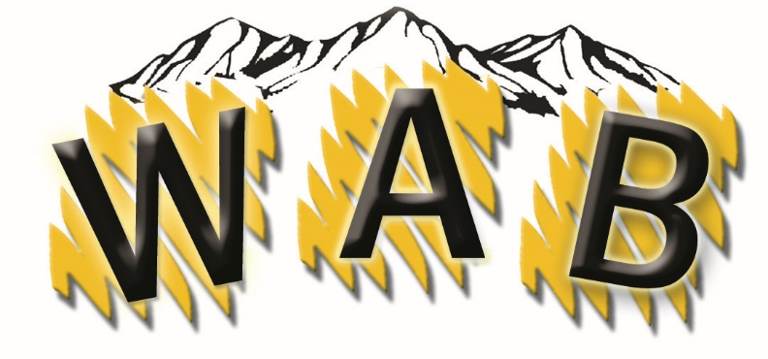

PUBLIC EDUCATION PROGRAM/PEP

WHAT IS A PEP PROGRAM?
The Wyoming Association of Broadcasters partners with our member stations to allow non-profit organizations to get their word out in an economical way!

STEPS TO GETTING YOUR AD ON THE AIR (Radio/TV/Both)

- Do you fit the criteria? You have to be a non-profit group that currently does not buy advertising on newspaper, billboard, etc. (Some exceptions will be considered).
- Call Laura to determine if we have your specific time-frame available.
- We will help you with a schedule that best fits your needs. ( 1 month minimum)
- Once you have an ad (:30 preferably) we will get you going and help you get the word out on your organization. We can also help you with production at an added cost.

WHAT IS THE COST PER MONTH?

Cost: $4,000 per month – to the WY Association of Broadcasters (radio or television). The cost is $8,000 for both radio and television.

WHAT SHOULD YOU EXPECT IN RETURN?

You will receive a statement approximately one month after the airing of your ads. We tell you which stations ran your ad, how many ads and the value of those ads. The WAB guarantees a 4:1 ratio on your investment or we will run the ads until we reach that value. This has never been a problem.

CURRENT/PAST PARTICIPANTS

- Army National Guard
- Office of Homeland Security
- Call Before You Dig
- Wyoming Beer Distributors Association
- VA
- Arch Coal Company – Teacher Awards
- USDA
- Brothers Redevelopment

Call WAB President, Laura Grott , (307) 632-7622 for more information or to set up your schedule. Get your word out!

lauragrott@gmail.com

