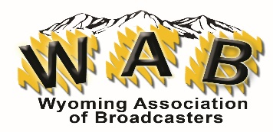
WAB 2024 CONVENTION - MEMBER REGISTRATION
Box 1387
Cheyenne, WY 82003

ONLY ONE REGISTRATION PER PERSON – DUE 5/27/2024
Name of attendee: Click or tap here to enter text.
Station: Click or tap here to enter text.
City: Click or tap here to enter text.
Please indicate the events you are attending:
☐Opening Reception – South of the Border Buffet - $25.00
☐Saturday Luncheon – Italian Buffet - $25.00
☐Saturday Banquet – REQUIRED FOOD CHOICE - $65.00
Please indicate your food choice for the banquet:
Choose an item.
For any other dietary needs, please contact Laura Grott @ lauragrott@gmail.com We cannot accommodate changes or dietary needs at the event.
Total: Click or tap here to enter text.
Please indicate your form of payment:
Choose an item.
If you want to be invoiced for credit card payment, indicate the email we should use for the invoice? If you selected multiple registrations from the station, I will gather them all and send one email with the total for your stations.
Click or tap here to enter text. EMAIL FOR CC PAYMENT
T-Shirts will be available only for those who are attending the full day on Saturday and who get their registration in no later than: May 20, 2023. T-shirts won’t be available for banquet only registrants or those that register after May 20th.
Size of t-shirt
Choose an item.
NO REFUNDS OR CHANGES AFTER MAY 27TH.
☐I have received a copy of the code of conduct and agree to the terms.

