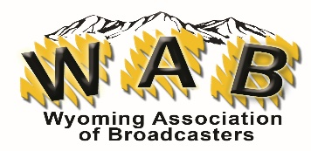
WAB 2024 CONVENTION - MEMBER REGISTRATION
P.O. Box 1387
Cheyenne, WY 82003

BANQUET ONLY ATTENDANCE – Use additional pages as needed
DEADLINE: 5/27/2024
Registrants: Station: Click or tap here to enter text.
Names of Attendee’s:

Click or tap here to enter text.
Choose an item.
Click or tap here to enter text.
Choose an item.

Click or tap here to enter text.
Choose an item.
Click or tap here to enter text.
Choose an item.
Click or tap here to enter text.
Choose an item.
Click or tap here to enter text.
Choose an item.
Click or tap here to enter text.
Choose an item.
Click or tap here to enter text.
Choose an item.
Click or tap here to enter text.
Choose an item.
Click or tap here to enter text.

Choose an item.
Click or tap here to enter text.
Choose an item.
Click or tap here to enter text.
Choose an item.
Saturday Banquet - $65 each
For any other dietary needs, please contact Laura Grott @ lauragrott@gmail.com We cannot accommodate changes or dietary needs at the event.
Total: Click or tap here to enter text.
Please indicate your form of payment:
Choose an item.
If you want to be invoiced for credit card payment, what email should we use for the invoice? If you selected multiple registrations from the station, I will gather them all and send one email with the total for your stations.
Click or tap here to enter text. EMAIL FOR CC PAYMENT
NO REFUNDS OR CHANGES AFTER MAY 27TH.
Payment must accompany registration.
CODE OF CONDUCT
☐All of the above registrants have read and agree to the WAB’s Code of Conduct which accompanied this registration.

