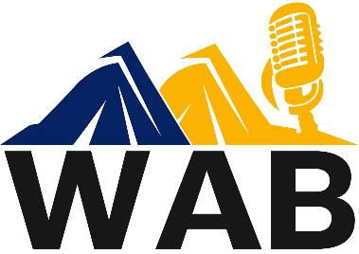
Box 1387
Cheyenne, WY 82003

WAB 2026 CONVENTION - MEMBER REGISTRATION
1 Per Registrant
DUE 5/19/2026
Name of attendee: Click or tap here to enter text.
Station: Click or tap here to enter text.
City: Click or tap here to enter text.
Please indicate the events you are attending:
☐Opening Reception - GR Bowling Center - Food/Bowling - $20.00
Do you plan to bowl? Choose an item.
☐Saturday Luncheon – Taco Bar - $20
☐Saturday Banquet – 10 oz. prime rib - $65
☐Saturday Banquet - Mediterranean Chicken - $35
Please make sure you make your appropriate selection above for the banquet.
Total: Click or tap here to enter text.
Please indicate your form of payment:
Choose an item.
If you want to be invoiced for credit card payment, indicate the email we should use for the invoice? If you selected multiple registrations from the station, you will receive one invoice for all.
Click or tap here to enter text. EMAIL FOR CC PAYMENT
REGISTRATION DUE: MAY 19th
NO REFUNDS OR CHANGES AFTER MAY 19TH
Host Hotel: Hampton Inn – 1055 Wild Horse Canyon Drive - Green River
Bowling Center – 1410 Uinta Drive – Green River (Friday event)
Banquet/Hall of Fame – Expedition Island - 475 S. 2nd Street – Green River

